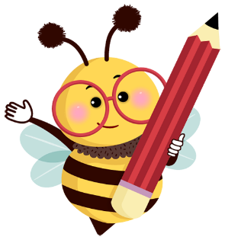

**Mrs. Chapin’s Suggested Supply List**

**Fifth Grade**

**2024-2025**

**Pencils (no mechanical pencils please!)**

**Small pencil sharpener**

**Highlighters (2-light colored)**

**Lined college ruled filler paper (3-hole punch)**

**Composition notebook-100 sheets (9 ¾ x 7 ½)**

**Folder/binder for organizing school subjects**

**Supply case (soft material)**

**Erasers**

**Ruler**

**Headphones for Chromebook**

**Please come to school prepared each day. Pencils should be sharpened, paper should be ready for use, and assignments should be easy to locate in your folder/binder. Please let me know if you have any questions or concerns.**

**Sincerely,**

**Mrs. Chapin**